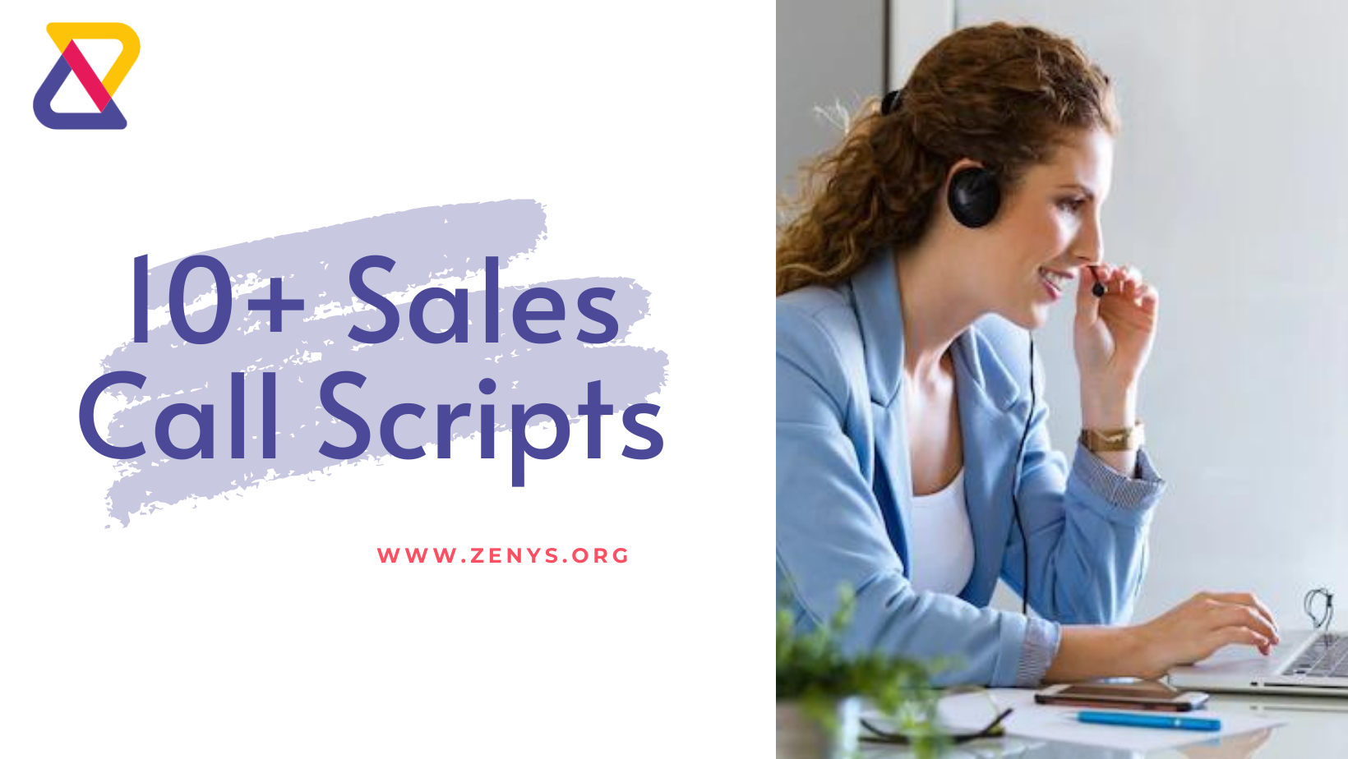

How to Use the Templates?

Use these cold call script as a guide to creating the best call script for sales no matter what industry you are in. We have compiled them into different scenarios. You can check them out and modify them the way you want based upon your industry. If you are using the same template, make sure to modify the phrases in brackets [], (). Insert sentences wherever it is highlighted in Italics.

Table of Contents
- Standard Cold Call Script
- Reply after objection
- Working with gatekeepers
- Referrals
- Voicemails
- Follow up for voice mails
- Using great Opening Lines
- Qualifying Prospects
- Following up
- Scheduling meetings or demo
- Special Offers

- Standard Cold Call Script

As mentioned above, before you make a call, conduct research about your lead so that you can build your conversation in a more engaging way. You can look at their qualification, job title, the industry they are working in etc. Once done you can follow a similar approach as shown in the template.

Template:

Hi [prospect’s name]. I am [your name] working as a [job title] in [company name]. Do you have a quick minute?

If you get a positive response continue as below.

I have noticed that you are working as a [job role] from your LinkedIn profile (or any other source). My company works with people like you to help with [your value proposition]. (Explain in a few more lines about how your product/service works for the prospect)

Would you be interested in knowing more about [your product/service]?

Assuming you get a positive response from the prospect.

Great! We would be more than happy to arrange a meeting or schedule a demo at your convenience. At what time would you be available?

Reply after Objection

After you have started off with your conversation it is not always likely that you get a positive response. However, you can continue the conversation as shown in the template below leaving you more chances to connect with the prospect later.

Template:

Hi [prospect’s name]. I am [your name] working as a [job title] in [company name]. Do you have a quick minute?

If you get a positive response continue as below.

I have noticed that you are working as a [job role] from your LinkedIn profile (or any other source). My company works with people like you to help with [your value proposition]. (Explain in a few more lines how your product/service works for the prospect)

Would you be interested in knowing more about [your product/service]?

If you get a negative response continue as below.

That’s fine. I will send you an email of our brochure (or any resources that clearly brief about your services/products). Please check it out if you get time. If you find it valuable, feel free to connect with me.

Thank you so much for your time.

Response to Gatekeepers

Sometimes you might not be able to connect with the right person directly. You will have to talk to assistants, managers or other subordinates first before connecting with the decision-maker. Here is how you can deal with them and get through to your prospect.

Template:

Hi [prospect’s name]. I am [your name] working as a [job title] in [company name].
Can I talk to [prospect’s name]?

Assuming the gatekeepers ask what the call is about.

It is regarding our product/service that we have recently launched. It can be beneficial for [prospect’s name] in [value proposition].

Referrals

A good way to establish a connection with your prospect is to mention your referral. It can help you gain trust from the prospect and establish yourself as credible. This template is about how you can use a referral in your conversation with the prospect.

Template:

Hi [prospect’s name]. I am [your name] working as a [job title] in [company name].

[referral’s name] mentioned that you are looking for [service/product you offer] and he/she suggested I give you a call. We specialize in [specialization]. We help [your target sector-probably the prospect’s industry] with [your value proposition].

If you are available next week (or any date as per your convenience) I would really be happy to arrange a meeting (or whatever next steps you would like to take).

Voicemails

60% of cold calls go to voicemail. (XANT). So, you need to be prepared with a script for a voicemail that has a higher possibility of getting you a call back.

Template:

Hi [prospect’s name]. This is [your name] from [company name]. I noticed that you are interested in [your product/service] from your LinkedIn profile [or any source]. (you can also use some other ways to establish a connection with your prospect).
I hoped to talk to you about our product that can help you with [value proposition]. If you are interested you can call me back on the same number. Have a great day!

Follow up for voice mails

In case you didn't get a reply from your prospect after you left a voice message, you should definitely follow up with them. This template is a follow up to the previous voice mail mentioning that you tried reaching out to them.

Template:

Hi [prospect’s name]. I am [your name] working as a [job title] in [company name]. I left a voice mail to you yesterday regarding our [ your product/service]. Since I didn't hear back from you, I thought I’d reach out today. I hope it is a good time to talk.

Assuming your prospect is interested to hear more about your product/service.

So, we specialize in [specialization]. We help [target sector] in [value proposition]. Since you are working in this industry our product could be really beneficial to you. If you want to discuss we can have a quick meeting tomorrow or any day of the week you are available.

Using great Opening Lines

To create a good first impression on your prospect you need to be very careful with how you start off your conversation. Using the best cold call opening lines, you can easily grab the attention of your prospects and build a rapport with them. They will be more interested in hearing you out.

Here are some best cold call opening lines you can use with any of the templates given.

- I saw that you work in [company name]. We share the same industry!
- I just saw your latest post on LinkedIn about [topic]. It was really good.
- Congratulations on your new job! (or any accomplishments)
- I noticed that you are a friend of [mutual friend’s name] on LinkedIn. He is my friend too!
- We recently followed each other on Instagram.

Qualifying Prospects

Cold calling is also about understanding the pain points of your prospects. Only if you know who your prospects are you will be able to provide them with the best solutions. That’s why you need to qualify your prospects by asking relevant questions. Understand their challenges and listen to their pain points. Take a look at this cold calling script for sales that can help you with discovering your prospect.

Template:

Hi [prospect’s name]. I am [your name] working as a [job title] in [company name].
We are a [company specialization] helping [value proposition]. I saw that you work in [industry]. Our current customers are mainly from your industry and they have found our product/service very beneficial.

Do you mind if I ask a few questions about [buyer persona challenges].

- What are the main challenges you are facing regarding your [buyer persona challenges]?
- How do you deal with them? Have you tried using any software?
- (If they have tried a solution)- What do you think is not working right with [the current solution they are using]
- What do you expect from your ideal solution?

Thank you for your cooperation. I think our [product/service] might be a perfect solution for you. (Brief in one line about how you can help your prospect)

We would be more than happy to arrange a meeting or schedule a demo at your convenience. At what time would you be available?

Following up

80% of sales require five follow-up calls after the first meeting with a prospect. (Brevet Group). If you have reached out to your prospect before via phone call or email, mention that you are connecting with him based upon the previous conversation.

Template:

Hi [prospect’s name]. This is [your name] from [company name]. I was wondering if you had a chance to look at the email I sent on [date].

Or

I am calling as a follow up to the previous conversation we had regarding [topic].

(Continue the conversation using the appropriate template given in this guide)

Special Offers

Special offers, discounts or freebies creates a positive impression about brands on almost 82% people. You can use this marketing strategy in your cold call that can bring you faster conversions. Here is a template that mentions promotional offers for prospects.

Template:

Hi [prospect’s name]. I am [your name] working as a [job title] in [company name].
We are a [company specialization] helping [value proposition].

We are offering special promotional offers for [time period of the offer]. I think this would be the best time for you to sign up for our product (any other ways to avail your product/service) if you are looking for [your product/ service]. Are you interested?

(Continue the conversation using the appropriate template given in this guide.)

Sector Specific Cold Call Scripts

Real Estate Cold Call Script

If you are working in the real estate industry you might need to follow a different script. The conversation should be brief and you need to get to the point quickly. As a bonus, we have also included 2 real estate cold call script templates.

Selling a Property
Template:

Hi [prospect’s name]. I am [your name] from [organization]. I saw that you have a property for sale in [area]. I know some clients who are interested in properties like yours. Do have a quick minute to share the details of the property?

(If yes, you can ask questions regarding the property to your prospect)

Recent Sales
Template:

Hi [prospect’s name]. I am [your name] from [organization]. I have recently sold a property near your area. There are few buyers I know who are interested in properties like yours. Are you planning on selling your property in the near future?

(If yes, you can ask questions regarding the property to your prospect)

Cold Call Script for Insurance
In the Insurance sector, cold calling is one of the most effective ways to connect with potential customers. Here we have the most commonly needed cold scripts for insurance agents.

Value Pitch

Template:

Hi [propsect’s name]. This is [your name] from [organization]. (Briefly mention in one line about your organization).

We have launched an investment plan for [target sector]. The benefits include [benefits and how it is better than other existing plans]. Do you have a few minutes for me to discuss the policy?

Assuming a positive response from the prospect.

(Explain the details of the investment plan and the benefits)

Can I please have your email address so that I can send you the details? Also, we would be more than happy if we could have a meeting this week to discuss the policy. Would you be interested?

Offering free quote
Template:

Hi [propsect’s name]. This is [your name] from [organization].

I wanted to let you know that our company is providing free quotes for many policies. You do not have to purchase them. This is just for you to see what all insurance choices are available for you and your family. Would you be interested?

For prospects who have existing policies

Template:

Hi [propsect’s name]. This is [your name] from [organization]. (Briefly mention in one line about your organization).

We have launched an investment plan for [target sector]. The benefits include [benefits and how it is better than other existing plans].

(When the prospect mentions that they are having existing polices, continue as below.)

May I know which policy you got?

(After the prospect replies mention the benefits of your policy and how it is better than your prospect's policy)

